Conditional Statements in C
Platform: HackerRank
Language: C
Module 2, Question 1

Problem Link
https://www.hackerrank.com/challenges/conditional-statements-in-c/problem

Problem Statement
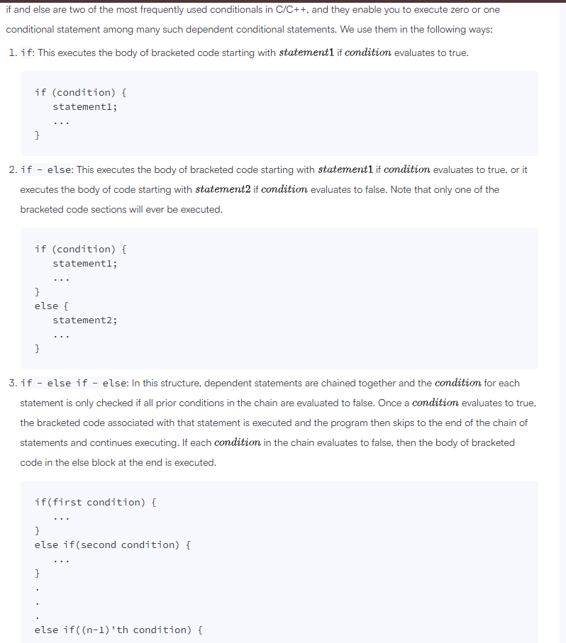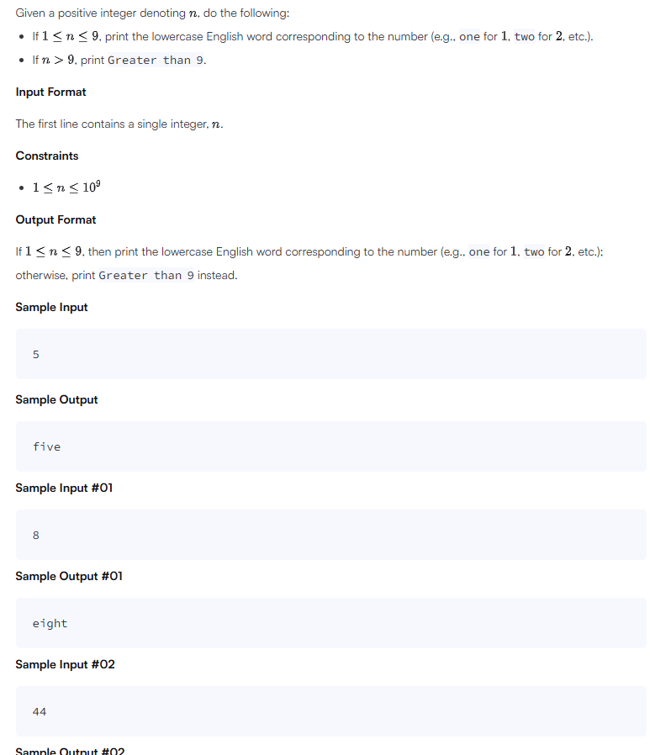

C Code
#include <stdio.h>

int main() {
int n;
scanf("%d", &n);

if (n == 1) printf("one");
else if (n == 2) printf("two");
else if (n == 3) printf("three");
else if (n == 4) printf("four");
else if (n == 5) printf("five");
else if (n == 6) printf("six");
else if (n == 7) printf("seven");
else if (n == 8) printf("eight");
else if (n == 9) printf("nine");
else printf("Greater than 9");

return 0;
}

Screenshot of Successful Submission



